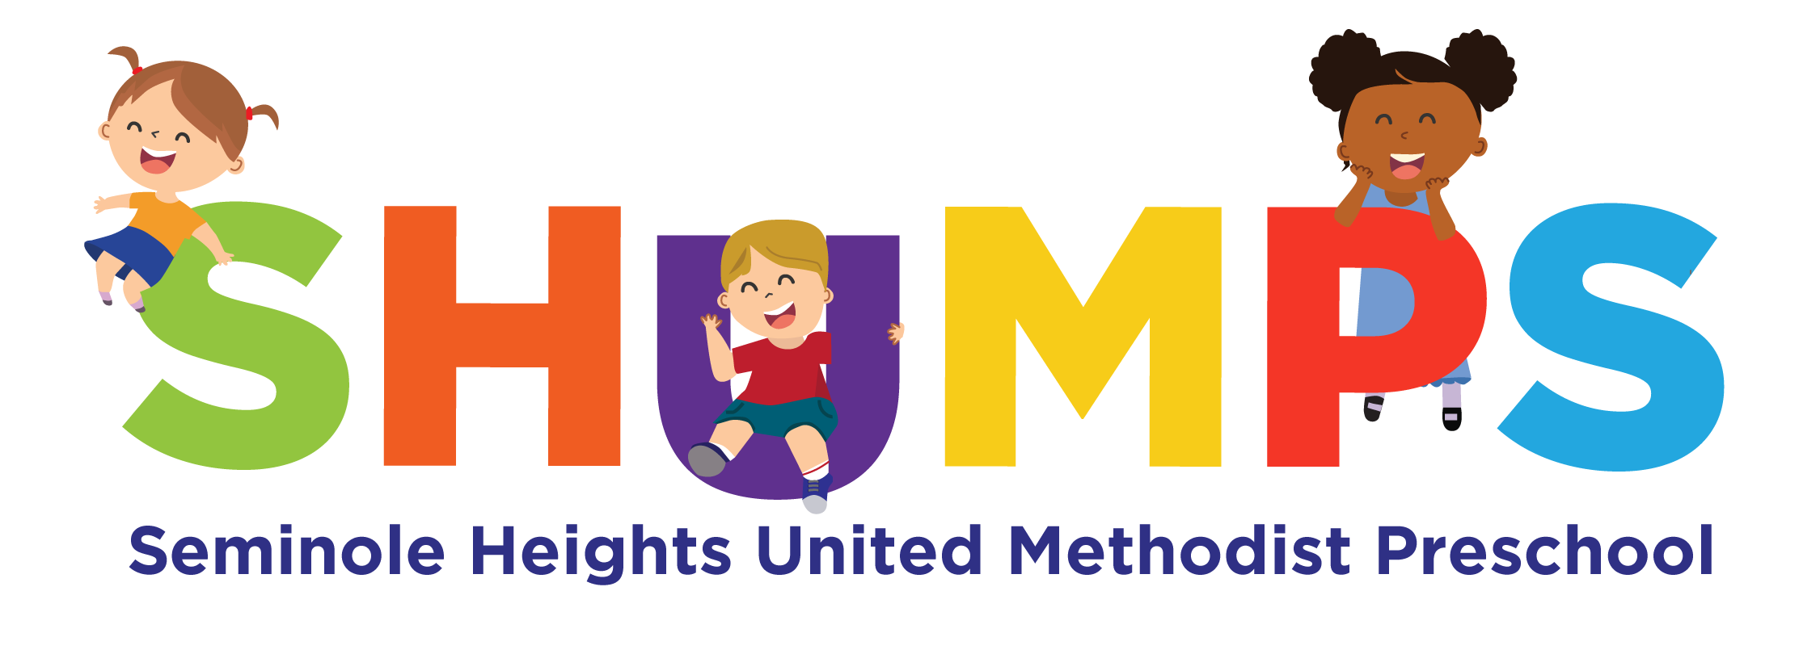
January 2025 6111 Central Ave.; Tampa, FL 33604 (813) 232-8231


And Again Happy New Year…

May the year of 2025 bring you much happiness and success. We look forward to continuing to care for your children. May God bless you!

SPAGHETTI FUNDRAISER … On January 6, 2025 we will have our first 2025 fundraiser. We will be offering a Take Out Spaghetti Dinner for $10.00 per plate, which includes spaghetti, garlic bread, and salad. Pick-up will be available between 4:00 PM – 5:30 PM.
To ensure we have enough meals prepared, please place your order no later than January 2, 2025. The sign up sheet will be at the front desk by sign in/out computer. All proceeds will go toward purchasing toys/supplies for the preschool playground.
Thank you for your support!

SCHOOL CLOSED…

Seminole Heights United Methodist Preschool will be closed on Monday, January 20 in observance of Dr. Martin Luther King, Jr. Day.

THANK YOU PARENTS…
For Our Staff Holiday Week:

For Goodies to Eat: To all the parents who gave goodies during Christmas for the staff. We truly enjoyed the treats.

For Gifts: We thank each of you who gave our staff individual gifts for Christmas. We appreciated everything.

For Missions: We also thank you for all the food and gifts given for Metropolitan Ministries.

For Books: To everyone who donated books to their child’s classroom, you are great! Books are so important and you have given a gift that will last a long time.

To Our Staff: You are the greatest!!!

SCHOLASTIC BOOK ORDERS …

These are due Wednesday,, January 15th.
Remember you can order and pay online and the more you order the more credit for books the school gets so thanks!

OUR CHRISTMAS PROGRAM WAS A HUGE SUCCESS…
We particularly thank all our teachers and children who planned and performed a great Christmas program. We are so blessed! Christmas is a magical time of year when we remember the people we should be, put aside our conflicts, and give of ourselves to each other…. and Jesus, this little baby born in a stable in the still of the night, is a symbol of this kind of spirit.
The sanctuary was full and we are grateful for all your support as always.

MARK YOUR CHILDREN’S THINGS…
Children’s clothing, particularly jackets and sweaters, as well as sippy cups, etc. must be labeled with your child’s name.
Please help us make this happen.
Also, make sure your child has a change of clothing here in case of accidents. If we give your child something to wear from our clothing, make sure we get it back.

PLEASE MAKE SURE YOU SIGN IN & OUT ON THE COMPUTER PROPERLY.

Positive Behavior
Support…Young children who
do more of the following behaviors are more likely to have friends. Help them by modeling what you want them to say.
- Organizing play using “Let’s” statements, such as “Let’s play trucks. You be the driver.” or “Roll it to me.”
- Sharing using words like “Can I have some paint?” and giving into requests from peers “Yes, I’ll give you a crayon”
- Assisting others by helping each other on or off of a play toy, telling or showing a friend how to do something “I can help you” or assisting someone in distress “Are you OK? Do you want a hug?”
- Giving compliments “I like your picture. It looks just like your mom.”

LOOKING AHEAD…

SHUMPS Will Close Early at 5:00 p.m. on Thursday, February 6, 2025 for our bimonthly staff meeting. Please be on time to pick up your children. Thanks!



HAPPY BIRTHDAY TO YOU …
January 1 – Penelope
January 2- Luke
January 2 -Dawson S.
January 5 – Mrs. Alegna
January 15- Cesar C.
January 17- Millie S.
January 18- Mel
January 19- June
January 22 –Gabrielle O.
January 28-Giovanni
January 31- Mrs. Callie

Seminole Heights United Methodist Preschool
2025 Holiday Schedule

The center will be closed on the following days:

New Year’s Holiday – January 1, 2025

Martin Luther King Jr. Day – January 20, 2025

Good Friday – April 18, 2025

Memorial Day – May 26, 2025

Independence Day Holiday – July 4, 2025

Teacher Work Day – August 8, 2025

Labor Day – September 1, 2025

Thanksgiving Break – November 26, 27, and 28, 2025

Christmas Holidays - December 24, 25 and 26, 2025

New Year’s Holiday-December 31, January 1, 2, 2025

(NOTE: On February 6; April 3; June 5; October 2;
December 4, 2025 SHUMPS will be closing
early at 5:00 p.m. for staff meetings.
Late pick up fee will be $5 per minute
after 5:00 p.m. on those days.)

