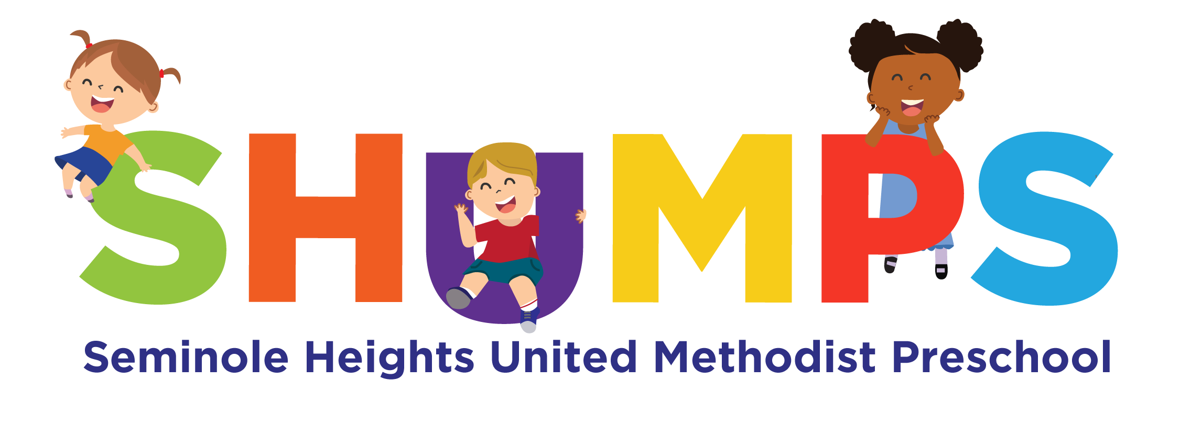
December 2024 6111 Central Ave. Tampa, FL 33604 (813) 232-8231

Christmas and New Year’s Holidays...
Seminole Heights United Methodist Preschool will be closed December 23rd, 24th and 25th. We also will be closed on December 30 th and 31st and will be closed on January 1st for New Year’s Day. Have a blessed holiday season!
SHUMPS Will Close Early at 5:00 p.m. on Thursday, December 5, 2024 for our bimonthly staff
meeting. Please be on time to pick up your
children. Thanks!
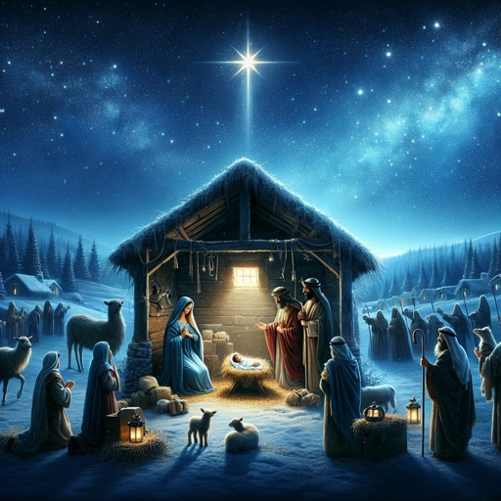
“Celebrating Jesus Birthday”
SHUMPS Children’s Christmas Program Friday, December 13, 2024 at 6:30 p.m. in the church sanctuary…
Please join us as all the children of our preschool celebrate the Birth of our Lord and Savior, Jesus Christ. Parents, we hope everyone can take part as our children remind us about the real meaning of Christmas. Please let your teacher know if your child will be participating.

Christmas Spirit Week ... Spirit Week is coming soon! December 16-20. Children and staff will be able to show their school spirit by dressing according to our theme for the day. The themes for each day are as follows:
Monday, December16-Wear red and green
Tuesday, December 17- Wear a Santa hat, reindeer antlers or elf hat
Wednesday, December 18-Dress up as your favorite character
Thursday, December 19-wear your favorite Christmas ugly sweater
Friday, December 20-Wear Christmas pajamas

Scholastic Book Orders …
These are due Friday, December 13. We hope to get the books back before Christmas. Remember you can order on-line.

Gift of Reading Continues…
The children of SHUMPS do not do a Christmas “gift
exchange”. As an alternative, we would like to suggest that each child bring a new, gift-wrapped book as a gift to his or her
class as a whole. Children love books and every child has a favorite! You can make it exciting for your child to go on a very special “book hunt”. Before wrapping the book, you can have your child endorse it over to the class inside the front cover. Then, every time your teachers read the book to the class, they can remind the class that the book was a special gift to them from your child. What a way to make your child feel extraordinary! If you don’t have time to get to the bookstore, you can let your fingers do your walking by ordering from Scholastic. The order forms come out each month!

After wrapping the book, please write your class name on a tag. When you bring in the wrapped book, we will help your child place it under the Christmas tree that is in the hallway. Thank you in advance and Happy Holidays!

To the Parents of our Afterschoolers and VPKers … Those afterschoolers who stay the two weeks of Public School Christmas Break will be charged $74 for the week of December 23 and $74 for week of December 30.

There is NO 3 hour VPK Dec. 23 – Jan 3.
The cost for VPK wrap around the week of Dec. 23 will be $82 and $82 for the week of Dec. 30. Please let us know in advance if your child will be attending.

“Be God’s Child”

Positive Behavior
Support…
God makes and keeps
a promise to Mary and the world. The Baby Jesus is born. Read the stories in Luke 1 and Luke 2. Pray with your child “Dear God, thank you for your Son, Jesus and please help us share in your plan for the world”.


Please keep your children by your side at all times coming to SHUMPS and going home from SHUMPS. Children may go running into the parking lot and get hurt. Unfortunately, not all people follow the traffic pattern correctly. Thanks for your help.
Wash Hands frequently!
It takes 20 seconds or singing the “Happy Birthday” song twice to kill most of the germs on your hands. This continues to be so important with everything going on with COVID-19.

Vacations…
The holidays are fast approaching and some of you may want to take vacation time with your families. Our policy is found in your Parent Handbook and states:
“All children enrolled in our program are on a regular weekly schedule, with a special weekly rate. For this reason NO REDUCTIONS will be made for absences, holidays or vacations! Children already in this program are entitled to two weeks of absences each calendar year. These are only available after three months of attendance from the date of enrollment, and must be taken as a full week (Monday – Friday) out of the school with written notice to the office. These can be used for vacation or sickness. For any additional weeks of absence, you will be charged the regular weekly rate! This policy will be enforced! Also, please keep in mind in order to be eligible for this vacation time your account must be at a zero balance.
Toy and Canned food collection…

We will collect for Metropolitan Ministries who in turn help needy and hurting families. It is important to teach our children early about the joy of giving to others. We will collect food and unwrapped toys until 12/17/24.

Free Dinner & Messy Church …December 18 @ 5:30 pm. – A Christmas celebration with our kids along with our weekly free dinner.

Christmas Eve Candlelight Worship… @ 4:30 pm. & 7:00 pm- A message of hope, classic carols and singing a candlelit “Silent Night”.

Community Christmas Dinner… December 25 @ 5:30 pm.- Open to everyone

Public School and SHUMPS Closures…
December 16 – December 20 -SHUMPS Christmas Spirit Week
December 23 – January 3 – Public School closed (For our schoolage children staying with us on days we are open part of those weeks - see the cost on page 1)
December 23 - January 3 - No VPK (For those in our extended day program learning continues while we are open. (See cost on page 1 for those in care the days we are open)
December 23, 24 & 25 – SHUMPS closed for Christmas
December 30 and 31 – SHUMPS closed
January 1 - SHUMPS closed in celebration at New Year’s Day
REMEMBER … JESUS IS THE REASON FOR THIS HOLIDAY TIME. MAY GOD BLESS YOU WHILE WE REMEMBER THE BIRTH OF HIS SON, JESUS CHRIST”


TO YOU
Alejandro R. – December 2
Ms. Brianna- December 3
Patrick R.-December 4
Londynn R.- December 6
Ace M.-December 8
Ms. Becca – December 10
Mrs. Alex-December 14
Austin B.- December 16
Leo C.- December 17
Lucy S.- December 31


HAPPY HOLIDAYS FROM THE STAFF OF SEMINOLE HEIGHTS
UNITED METHODIST PRESCHOOL

Ms. Elaine Mrs. Phyllis
Ms. Adile Mrs. Arlene
Mrs. Calie Ms. Annabelle
Mrs. Yesenia Mrs. Mariela
Mrs. Vienna Mrs. Rachel
Mrs. Teresa Mrs. Alex
Ms. Amanda Mrs. Saily
Mrs. Shelley Ms. Becca
Mrs. Lauren Mrs. Shane
Mrs. Alessandra Mrs. Kathy
Ms. Brianna Mrs. Johelice Mrs. Waleska Mrs. Alegna

