The News From Seminole Heights United Methodist Pre-School
November 2024 6111 Central Ave.; Tampa, FL 33604 (813) 232-8231


“Fall Back” – November 3rd – Daylight Savings Time Ends…

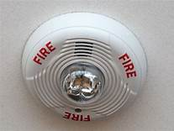
Also, change the batteries in your smoke detectors. Keep safe for all your families.

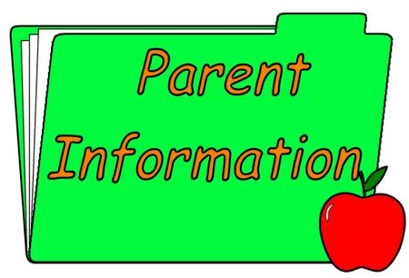
Join Us for Parent/Teacher Conference…

On Thursday, November 7th from 6-8 pm take the opportunity to find out how your child is doing and what they are learning here at SHUMPS. See your child’s teacher to schedule a time.
Open House, Parade & Parties and More Thanks… Thank you to everyone who attended our Open House and Storybook Parade! It was wonderful to see so many of you enjoying the festivities and learning more about the vibrant experiences we offer at SHUMPS.
A special shout-out to Jamie Farrell, Rebecca Crescentini, Alicia Damiano and Melissa Racobaldo for their hard work and dedication in preparing for the event. Your efforts made the open house and fundraising a tremendous success, and I’m pleased to share that we raised $2,097.32, which will be used to support our school’s needs.
I’d also like to extend my gratitude to all the volunteers who helped with setup, cleanup, the silent auction, fall pictures, and those who lent us tables. Your support made a significant difference.
Thank you once again for being such an engaged community. Our teachers truly do an incredible job, and it’s heartening to see our families come together to celebrate their work.

Scholastic Book Orders…
Book orders are due on Friday, November 15. The order code on-line is HWWZQ. NOTE: Those who ordered in October need to know that shipping from Scholastic has been delayed.

Important Notice for VPK Parents…
VPK will NOT be funded for Monday and Tuesday, November 25 to 26 , so there will be no school for our 3-hour VPKers. If your child is in wrap around VPK, the cost is still $82 for the week. If your child is not here and you do not have vacation time, the cost will still be $82. Remember in order to take vacation time you must have been here 3 months, you must be at a zero balance on tuition and give us notice of wanting vacation in writing.

Important Notice for Afterschool Parents…
The extra cost since public school is out for November 11 will be $15 extra and the cost for
November 25 and 26 for school age children will be $74 for the week if your child attends. If
not and they are not eligible for vacation, then the cost is still $74.

Important reminder …Please remember to bring a fitted sheet and blanket for your child every week.


Positive Behavior
“Be Respectful”

Support…
Show kindness and
courtesy. Being respectful starts with a basic consideration of other people’s feelings. First respect your child. Encourage them to use good manners (“Please”, “Thank You”, “May I”, “I’m Sorry”). Help them be respectful of other people by using inside voices and listening ears, keeping hands and feet to themselves, being responsible to clean up after themselves, and also teach them to respect people who are different from them.

Positive Behavior
“Be God’s Child”

Support…
Prayer is much
needed for every aspect of our lives, our community, our nation and our world. Children can pray with such simplicity and honesty if given the opportunity. Please make prayer an important part of your lives.

Thanksgiving Bible Verses…
- Give thanks to the Lord for He is good; His love endures forever. (1 Chronicles 16:34)
- In everything give thanks, for this is God’s will for you in Jesus Christ.
(1 Thessalonians 5:18)
Practice an attitude of thankfulness as we move forward into this busy time of the year. God bless you all.

Seminole Heights United Methodist Church offers free Dinner every Wednesday at 5:30. !

Church Holiday Craft & Bake Sale…
Plants, holiday crafts, Christmas decorations, collectibles, teacher gifts, vendor booths, plus our Country Kitchen with baked goods, jams and jellies, homemade pickles, salsas, candy and more will be available on Saturday, November 23 from 8:00 am – 3:00 p.m.


Christmas Trees Pre-Orders… Christmas is coming, and we are pleased to once again offer the premium trees we're sure you will enjoy. Pre-orders (including payment) are due by Sunday, November 3. Trees will be available for pick up the day after Thanksgiving. Place your order at www.semheights.com/christmas-trees
Pre-Order Prices
5 ft.: $70 6 ft.: $90 7 ft.: $100
8 ft.: $130 9 ft.: $160

Mark your calendar…
November 3 – Daylight Savings Time Ends November 7 week – Parent Conference Week
November 11 – No public school – We are open
November 15 – Scholastic Book Orders Due
November 25 - 26 - No public school
November 27, 28 & 29 – Thanksgiving Holidays
We are closed. Have a blessed holiday!!!

Looking Ahead…
December 5 – SHUMPS closes at 5:00 p.m.
December 13 – Preschool Christmas Program
December 23, 24 and 25 – Christmas Holidays –
SHUMPS closed
December 30 and 31 – SHUMPS closed



HAPPY BIRTHDAY TO YOU …

Mrs. Phyllis-November 4
Arsene D. – November 11
Alexander R. – November 13
Lillian F.-November 13
Dexter W.-November 28
Levi W.-November 30
Damien B.- November 30

